1. **The following flowchart classifies animals as herbivore or carnivore. Lion is a meat-eating animal. Elephants eat only plants. Study the flowchart and answer the questions.**

O

O

D

I

a. Indicate each element of the flowchart by putting ‘I’ for input, ‘O’ for output, ‘D’ for

decision next to the appropriate boxes.

b. Put a rectangle around the decision structure. (Use the **Draw** dropdown from the menu bar, pick a red pen then draw your rectangle in the appropriate place)



c. What is the condition which classifies an animal as carnivore?

No.

d. Write the execution steps if the input is a Lion.

Start,

Read the name of the animal: Lion

Does it only eat plants?: No

Print Carnivore: Carnivore

End.

e. What is the condition which classifies an animal as herbivore?

Yes

f. Write the execution steps if the input is an elephant.

Start,

Read the name of the animal: elephant

Does it only eat plants?: yes

Print Herbivore: Herbivore

End.

2. **A, B, C are the marks scored by a student in Science, Mathematics and English. Refer the flowchart and answer the questions.**

|  |  |  |
| --- | --- | --- |
| Do better to get a star  no  yes  Is Average>=75  Award a star | 1. Jessica scores 60 marks in Science, 70 marks in mathematics and 75 marks in English. Use the adjacent flowchart and provide the execution steps in calculating Jessica's average mark. The first step is given. (type your answer in the box)  |  | | --- | | Start  A=60, b=70, C=75  Sum= 60+70+75  Average = 205/3  68.3333333… |  1. A student whose average mark is above 75 is awarded a star. Fill in the following phrases in the flowchart for finding if a student gets a star or not.   Yes  No  Award a star  Do better to get a star  Is average greater than 75 |

1. Is Jessica awarded a star? Yes or No?

Ans:

|  |
| --- |
| no |

1. Marks of two more students are given below. Study it and fill in the blanks with the average marks of each student and whether the student is awarded a star or not.

|  |  |  |  |
| --- | --- | --- | --- |
|  | Science | Mathematics | English |
| Emma | 75 | 80 | 72 |
| Darrell | 72 | 70 | 82 |

Emma’s average is _75.7___, so she is ___Awarded________ a star.

Darrell’s average is _74.7_, so he is ____not awarded__________ a star.

1. The following empty flowchart gives the steps to be followed while seeking admission to a new school. The phrases to be filled in the boxes are also given. Complete the flowchart by filling in the number of the corresponding phrase, inside each box. For example: the number corresponding to the first box in the flowchart is 7.

|  |  |
| --- | --- |
| 5  4  8  3  2  6  1 | 1. Search for a school. 2. Prepare for the admission test and write the test. 3. Did you pass the exam? 4. Submit necessary documents and get admission. 5. End. 6. Are seats available? 7. Start. 8. Is there an admission test? |

1. The following flowchart gives the steps followed while taking attendance in a class. Three arrows and a loop are missing. Complete the flowchart as follows:

1. Draw the three missing arrows and loop at the correct place. (Use the **Insert** dropdown from the menu bar, pick **Shapes** then pick **Connectors: elbow arrow** then draw your lines in the appropriate places)
2. Label the decision arrows with yes or no.

Yes

No

yes

1. There are four types of fruits: Apples, Oranges, Bananas, and Grapes. Each student can pick up two fruits. There are some conditions which must be used to pick up the fruits. Draw a flow chart which can take the name of the first fruit as an input and print the name of the fruits that can be picked up. The conditions are:

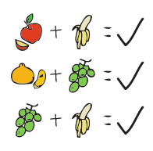

* If you pick an apple, you can pick banana.
* If you pick orange, you can pick grapes.
* If you pick grapes, you can pick banana.
* *Hint: There will be one input box to read the first fruit, three decision boxes and four output boxes in the flowchart.*
* Move around the shapes on the next page to create your flowchart.
  + you may want to resize the shapes to fit the flowchart on one page.
  + You can type the appropriate information into each shape by clicking on the shape and start typing.
  + Remember to use the **Insert** dropdown from the menu bar, pick **Shapes** then pick **Connectors: elbow arrow** then draw your lines in the appropriate places.

Start

Input Fruit

Did you pick apple

You can pick banana

Did you pick orange

You can pick grapes

Did you pick grapes

You can pick banana

Print Fruit + fruit

End

1. Lengths of three sides of a triangle a, b, c are given as input. The following flowchart finds if the triangle is isosceles, equilateral, or scalene. Some boxes in the flowchart are filled in for you, fill in the rest of the details.

*Hint: In an equilateral triangle three sides are equal.*

*In an isosceles triangle two sides are equal.*

*In a scalene triangle three sides are not equal.*

The red boxes are where you can type in the yes or no related to the decision box.

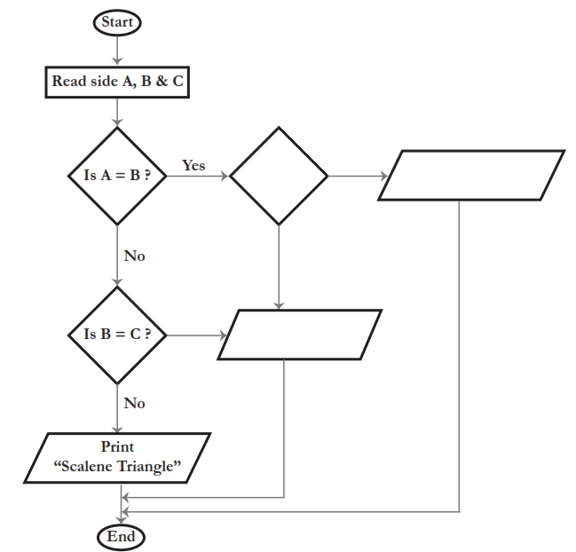

yes

no

Print “*isosceles Triangle”*

Print “equilateral Triangle”

Is B =C

1. Use the above flowchart **and provide the execution steps** in finding whether the given triangle with sides 5 cm, 5 cm and 3 cm **is scalene or isosceles or equilateral triangle**.

|  |
| --- |
| Start  Read sides: A=5, B=5, C=3  Is A == B: yes  Is B == C: no  Print isosceles Triangle  Stop |